Broad Oak Community Primary School
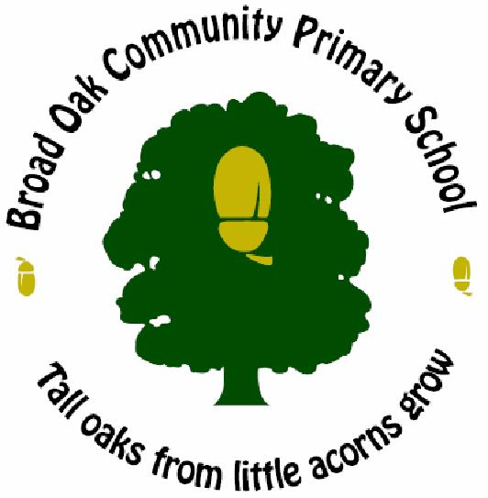
British Values

 | Autumn 1 | Autumn 2 | Spring 1 | Spring 2 | Summer 1 | Summer 2
Reception | Our United Kingdom (Little passports, Union Jack/flag) | Globes- Britain as part of the World | Natural British features (seaside/pirates) | British iconic buildings | Money  The Royal Family | Britain in the World
Year 1 | British Passports | Our United Kingdom | Debate (democracy) | British music | Local transport | Money
Year 2 | The Queen | UK countries  British Authors | Climate & contrasts  Food | Me in the World | UK artists | Seaside traditions
Year 3 | Countries, cities and natural features | Great British inventors | Famous British writers | History of St. Helens | British pop music | British sports
Year 4 | Famous British women (Boudicca) | British legal system  Parliament | Famous British stories e.g. Robin Hood | BBC | British heroes | British iconic buildings and architecture
Year 5 | British Institutions Emergency Services (Crucial Crew) | British beliefs  Anglo-Saxon convert to Christianity | Politics  Churchill (WW2) | Timeline of Prime Ministers since WW2 | Debate (democracy)  Rainforest  Protecting the environment  Energy | London transport  system  London sights
Year 6 | Elect a Committee  School Council | Right to free speech | Modern living  Britain’s inspirational people | Supporting the family | Keeping healthy | British pop songs

