Task 1: Can you subtract 20 to these numbers?
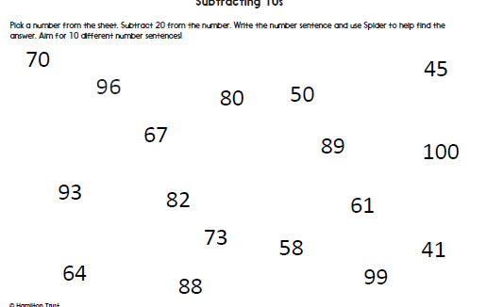
Here’s a 100 square to help you!
