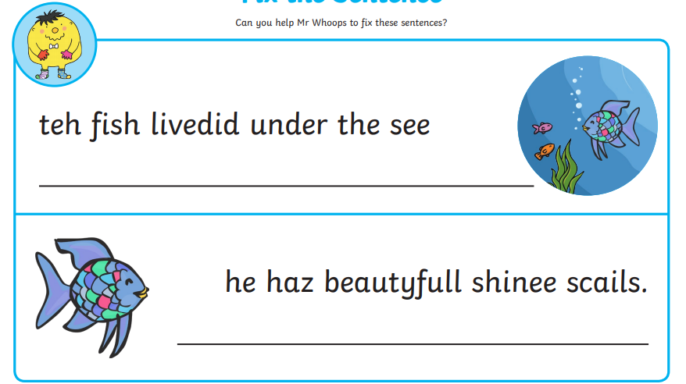
Clue: Capital letters, full stops, finger spaces, use your phonics.

Challenge: Can you create your own sentences to describe the Rainbow Fish? Can you include 2 adjectives?

