Creative Writing
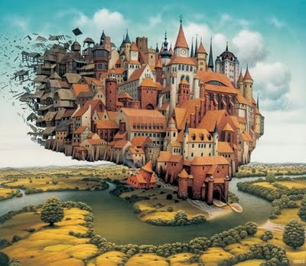

“THE TOWN… IT’S… IT’S… STARTING TO COLLAPSE AND FLOAT AWAY!” screamed Milly, as she stared in shock at the quickly disappearing town of Willow.
“What are we going to do?!” questioned Matt, with a worried expression, frozen to the spot, helpless.

