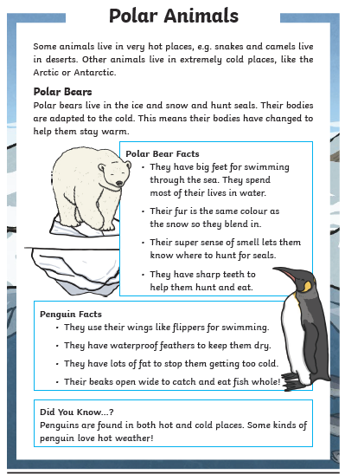
R Retrieve | Name one animal found in the dessert. | ______________________________
R Retrieve | What do polar bears hunt? | ______________________________
V Vocabulary | Find and copy one word which means ‘changed to help them.’ | _____________________________
E Explain | What do penguins use their wings for? | ______________________________  ______________________________
E Explain | Can you explain what polar bears’ feet are useful for? | _______________________________
R Retrieve | Can you find one animal who has big feet for swimming through the sea? | _______________________________

