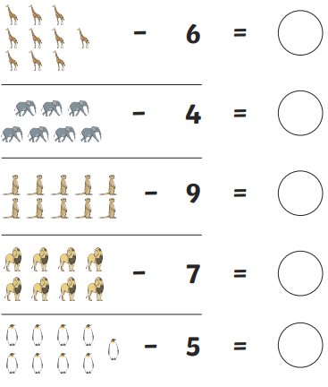

12.1.21

Subtraction.

LO: To take away by crossing out.

Task: Can you read the number sentence then take away the amount shown by crossing out. The first one is done for you.