12.1.21.
Subtraction.
LO: To write a subtraction sentence.
Task: Look at the objects then write the subtraction sentence on the line next to it. The first one has been done to show you
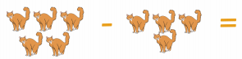
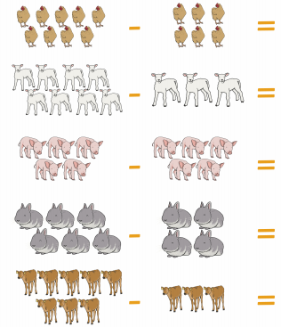

5 – 4 = 1

