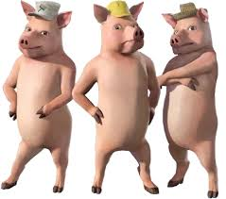

**Facts** – a fact is something that is the truth, we cannot make up facts. When writing a newspaper report we cannot make up any of the story we must just use facts (the truth).

**Quote** – something that someone involved in the story has said.

**Caption**– a very shot sentence that tells the reader who or what is happening in the picture.

**Picture**– shows the reader what has happened or who was involved.

**Heading** – tells the reader what the story is about.

Wednesday 13th January 2021

**The Broad Oak Times**

**3 Little Pigs see off wolf!**

The three little pigs, Peter, Patty and Penny.

The wolf suffered terrible burns from the fire at the bottom of the chimney.

The three little pigs are hero’s in their local village.

The Big Bad Wolf won’t be bothering the residents of Fairy-tale Town ever again.

It was a bright, sunny morning when 3 Little Pigs Peter, Patty and Penny decided to build new houses. Peter made his house of yellow, thin straw and Patty made her house of small, brown sticks. The Big Bad Wolf of Fairy-tale Town blew both houses down.

Patty said, “It was terrifying! I thought he was going to eat us”

Luckily the oldest pig Penny, decided to make her house of bricks to keep the pigs safe. When the wolf couldn’t blow her house down, he decided would happen” said The Big Bad Wolf.