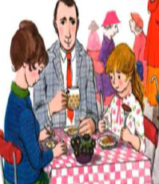
Wednesday 13th January
Once you have had a look at the Three Little Pigs example, have a go at labelling the different features if this newspaper report about the tiger coming for tea. Use the word bank at the bottom to help you.
Wednesday 13th January 2021
The Broad Oak Times

A Tiger Came for Tea!

Sophie, her mother and her father.
The family ended up eating supper at a local café. They enjoyed a supper of Sausages, chips and ice cream.
Sophie and her mother stocked up on Tiger food in case the tiger returned, by so far he hasn’t returned.

Sophie was having tea with her mum when, to their surprise, a tiger came to the door. The huge, furry tiger stayed and had tea with Sophie and her shocked mother.
Sophie said, “I couldn’t believe there was a real tiger in my house it was so exciting!”
Sophie’s mum said, “I could not believe how much food he ate, we had nothing left in the house by the time he left!”
When Sophie’s father returned from work there wasn’t a single thing to eat or drink in the house.

Word Bank
heading picture caption facts
quote

