Home Learning task: 21.1.21

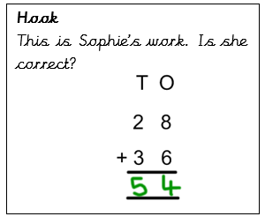Explain your answer.

Task 1



Task 2:

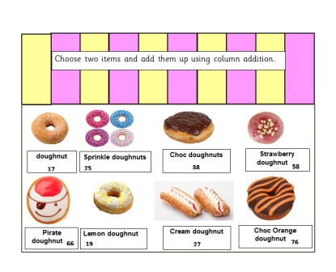

Can you add up any more pairs of items and record your column additions below?