Monday 1st February

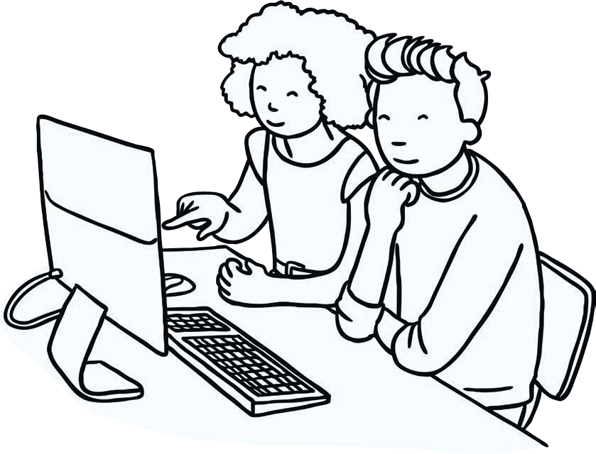

Using what you have learnt from Buddy the Dog, create your own poster about internet safety.

**t**