**Teacher Example**

**They’re Going on a Bear Hunt**

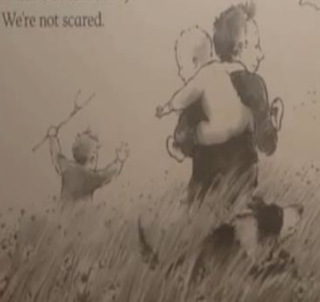

One day, a family decided to go on a bear hunt. It was a beautiful day and they weren’t scared!

On the way they found a field of long, green grass. They couldn’t go over it and they couldn’t go over it, so they decided to go through it. It was very difficult to get through the long, green grass.

Next, they found a deep, cold river. They couldn’t go over it, they couldn’t go over it, so they had to go through it. The river was freezing cold and the family got soaked.

Then, the family came to a field of thick, sticky mud. They couldn’t go over it, they couldn’t go under it, so they had to go through it. The mud was smelly and so difficult to walk through. It made a squelching noise.

They carried on and found a dark, spooky forest. They couldn’t go over it, they couldn’t go over it, so they had to go through it. The family where very scared and kept falling over.

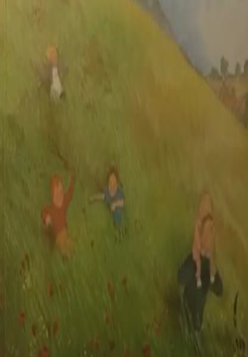

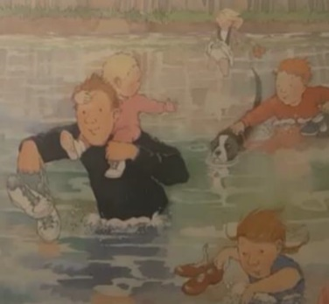

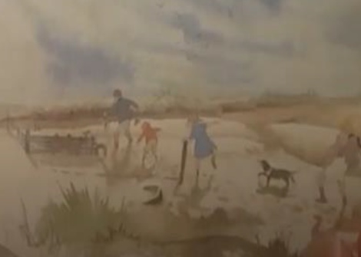

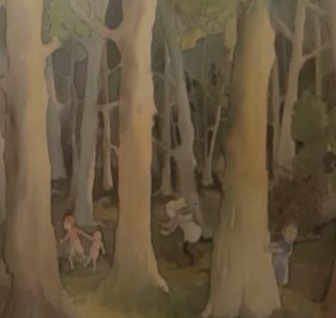

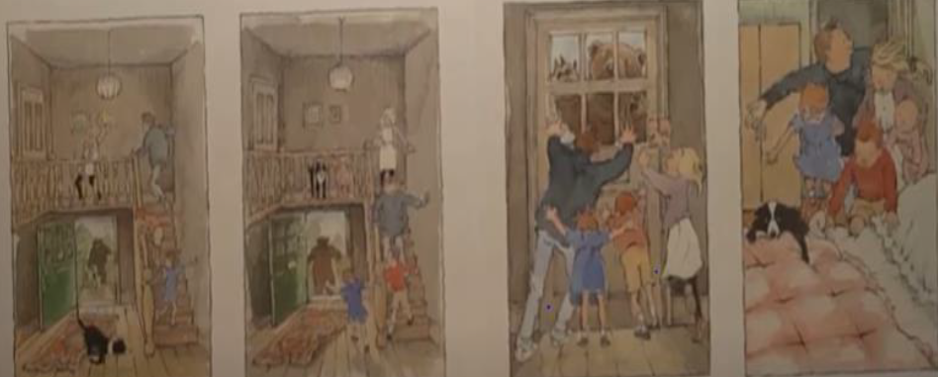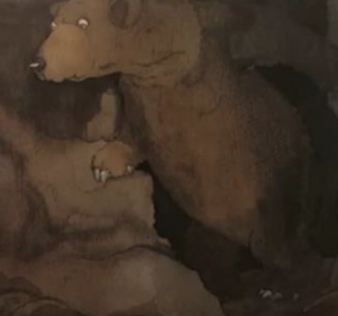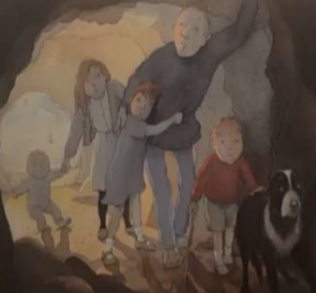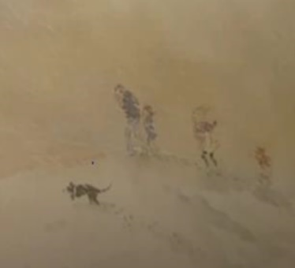

They ran back through the cave, through the snowstorm, through the forest, through the mud, through the river and through the long green grass. They got to their front door and barged through it. They locked the door, ran upstairs and hid under the covers. They will never go on a bear hunt again.

Next, they came to a huge, swirling snowstorm. They couldn’t go over it, they couldn’t go under, so they had to go through it. The family stomped through the thick, freezing snow. They where so tired.

Suddenly they came to a dark, spooky cave. They couldn’t go over it, they couldn’t go under it they had to go through it. They where terrified. The cave was damp, cold and scary.

Suddenly, they saw brown fur, a black wet nose and huge claws. It was a terrifying bear.