Task 1:
Look at the five numbers in each box.
Use the strategies you have learned this week to solve the addition calculations.
Which three numbers add up to the total? Look for number doubles or number bonds to 10 which might help. Which 2 numbers will you add first? Why?

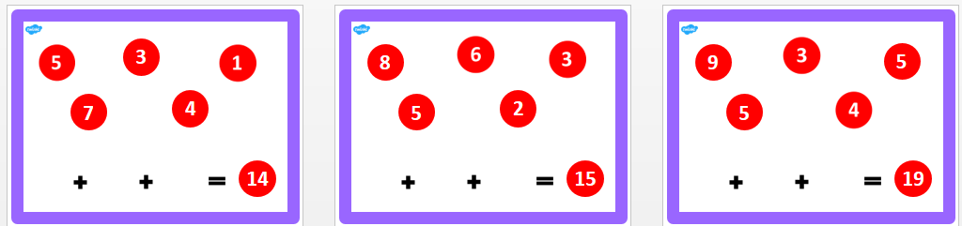
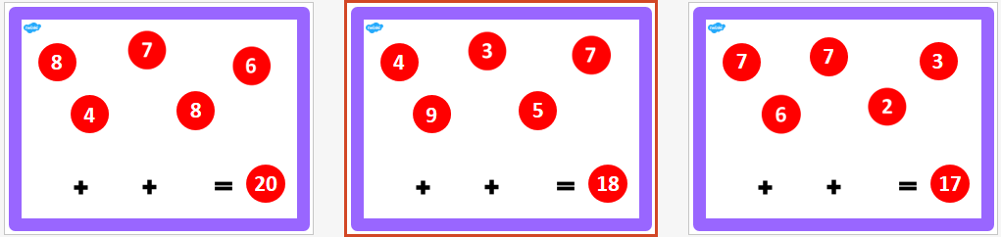

Task 2:
Three of these coins are in a purse.
How much money could be in the purse? How many different amounts can you find?
Show your working.

