Weekly Art Challenge
Hello and welcome to the weekly Art Challenge!
Everyone Monday I will post an art challenge for each phase. To take part, complete the challenge at home, then email a photograph of your work to the class email page.
Entries must be returned by Thursday to be included in Friday’s Virtual Gallery.
I love art and I can’t wait to see your work!
Mr. Winstanley
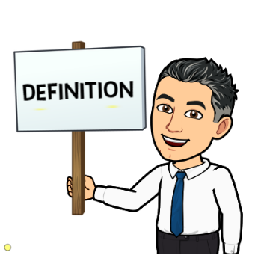
Gravity is an invisible force that pulls objects toward each other. Earth's gravity is what keeps you on the ground and what makes things fall.

Task:

- No Gravity – Look around the room that you are in, imagine if someone turned the gravity off. Nothing would stay on the ground! Imagine the mess! What would it look like?

