Running challenge- 5km Target | Bubble Results  1st Place  Year 6- 17.32km  2nd Place  Year 2- 9km  3rd Place  Year 4- 7km  Special Mentions to the children at home too….  Maja in Year 1- ran 7.17km  Braydon in Year 4 – walked 5km  Albert in Year 3- cycled 7 miles | Staff Results  - Mr Mackin (PEco Schools)- 18.3km (not included in the prizes)  - Miss Bowes- 7 km  - Ms Keyte – 12km (in and outside of school hours)  - Mrs Bancroft – 15km (outside and inside of school)  - Miss Lamb – 13.4km  - Mrs Bayliss – 5km  - Miss Lee – 7.5Km + 13.4km+2km (outside of school hours) 22.9Km  - Mr McGowan –10km (in and out of school)  - Mr Winstanley 10 km (outside school hours) | Total
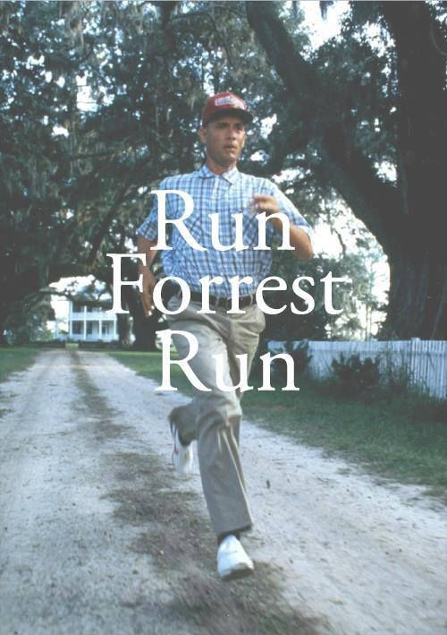 |  |  | 1ST Place  Miss Lee- 22.9km
2nd Place

Mrs Bancroft- 15km
3rd Place

Miss Lamb- 13.4km

