**How to Make a Paper Aeroplane**

**You will need:**

* A piece of A4 paper

**Method**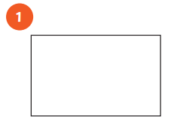

Take your piece of A4 paper and lay it flat.

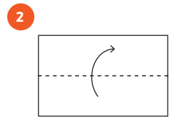

Make a line in the middle by folding the paper in half longways then opening it out flat.

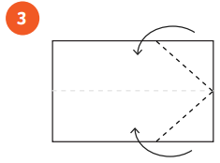

Fold in two of the corners so they meet at the line we have just made in the middle.

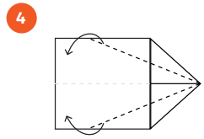

Fold the outer edges in again to meet at the middle line.

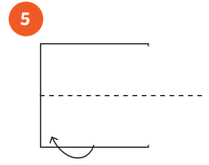

Turn the paper over and then fold it in half in the middle.

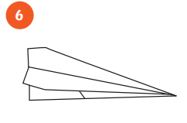

Fold down the wings on each side so that they meet with the bottom of the plane.

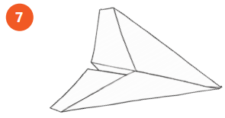

**Word Bank**

**Heading pictures verbs**

**you will need list**

**numbers method**

Now your plane is ready to fly! How far can you make it go?