**__________________________________**

**You will need:**

* A printout of a __________
* S_________
* S_____ p_____

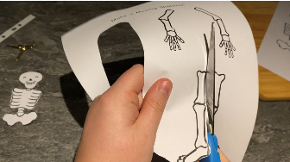 **Method   
1**

