**How to Make a Split Pin Skeleton**

**You will need:**

* A printout of a skeleton
* Scissors
* Split pins

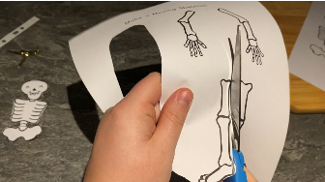 **Method   
1**

Carefully cut out the different parts of the skeleton.

Next, put one of the arms onto the skeleton. Push a split pin through and split the pin at the back.

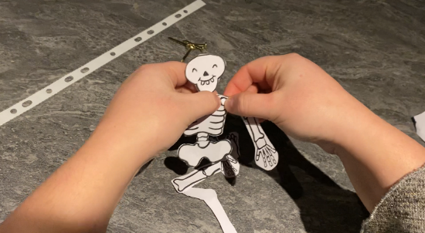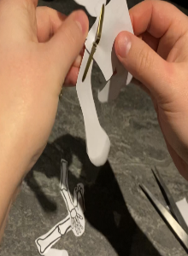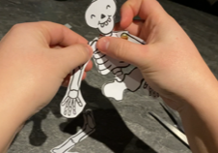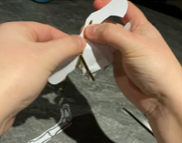

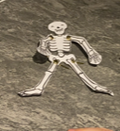 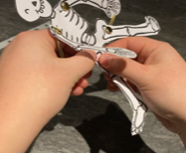

Now you have a split pin skeleton.

Finally, place the last leg onto the skeleton. Push a split pin through and split the pin at the back.

After that, put one of the legs onto the skeleton. Push a split pin through and split the pin at the back.

Then, put the other arm onto the skeleton. Push a split pin through and split the pin at the back.

