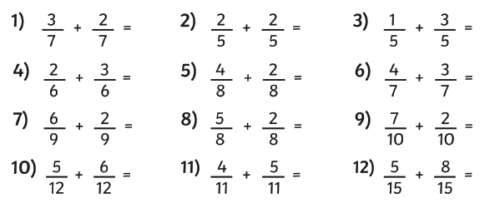Complete the fractions calculations in your home learning maths book.