Creative Writing

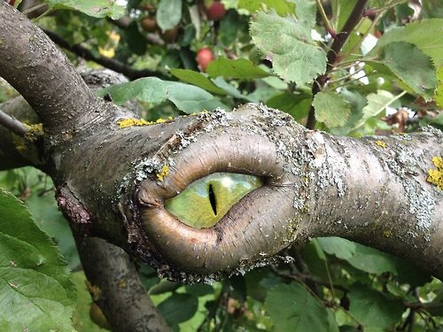

You are walking through a strange forest full of odd sounds and noises. You stop for a short rest, knowing that you want to get home as quickly as possible. You sit next to a tree. Hearing a noise you look next to you and see the tree LOOKING at you.

Using this information, write a short story. Be as creative as possible!