Relative pronouns - Charles Dickens

Complete the text about Charles Dickens using « who », « which » or « whose ».
Put a (-) if who and which are not necessary.

Charles Dickens was an English writer ………………. lived from 1812 to 1870. The books ……………… he wrote have been translated into many different languages.

Dickens, ………………………….. family was very poor, had to start work when he was very young. In England at that time, people ……………………. could not pay their debts were sent to prison. This happened to Dickens’ father ……………………. first name was John. So Dickens, …………………. was only a boy, had to visit his father in prison.

Later Dickens’ books were based on people ……….
he had known and places …………….he had lived in. For example in ‘David Copperfield’ he wrote about the prison visits ………………………… he paid to his father. In ‘Oliver Twist’ he described children …………………… were poor and he wrote about orphans – children …………………….. parents had died.

Dickens, ……………………….. was also a good actor, often read his stories himself to audiences in England and America.

He married a woman ……………………….. name was Catherine and …………………. father was, in fact, Dickens’ first publisher.
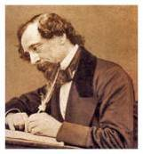

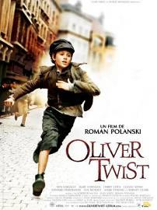

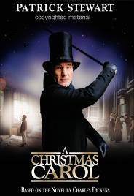

KEY

Charles Dickens was an English writer WHO lived from 1812 to 1870. The books (-) he wrote have been translated into many different languages.

Dickens, WHOSE family was very poor, had to start work when he was very young. In England at that time, people WHO could not pay their debts were sent to prison. This happened to Dickens’ father WHOSE first name was John. So Dickens, WHO was only a boy, had to visit his father in prison.

Later Dickens’ books were based on people (-) he had known and places (-) he had lived in. For example in ‘David Copperfield’ he wrote about the prison visits (-) he paid to his father. In ‘Oliver Twist’ he described children WHO were poor and he wrote about orphans – children WHOSE parents had died.

Dickens, WHO was also a good actor, often read his stories himself to audiences in England and America.

He married a woman WHOSE name was Catherine and WHOSE father was, in fact, Dickens’ first publisher.

